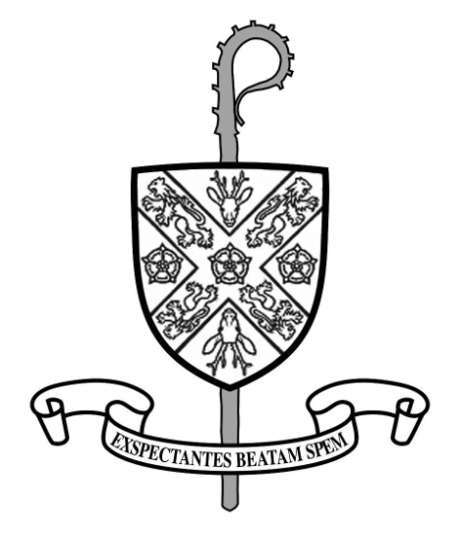 | SAINT MARY’S CATHEDRAL  Also serving Osmotherley and the Shrine of Mount Grace   01642597750 | 6th Sunday of Easter  (Year B)  10th May 2015  Divine Office: Week II

WELCOME
especially if you are a visitor, or worshipping with us for the first time

MASS TIMES & INTENTIONS DURING THIS WEEK
SACRAMENT OF RECONCILIATION
Saturday: 9.45 am to 10.30 am
5.45 pm to 6.15 pm and on request.

EXPOSITION OF THE BLESSED SACRAMENT (for Vocations)
Saturday: 9.45 am to 10.30 am.

MORNING PRAYER

Tuesday and Wednesday – 8.50 am

THE ROSARY (for Vocations)
Saturday morning – 8.50 am

BENEDICTION & SOLEMN VESPERS
Wednesday at 6pm

PRAYER GROUP
Resumes Monday May 18th
Saturday (Vigil) | 4.00 pm (Shrine)  6.30 pm | G&V Allinson  Bill Sigsworth
Sunday | 8.30 am (Osmotherley)  10.00 am  5.00 pm | Mary Philomena Salvatore  People of the Parish  Buckley Family
Monday | 6.30 pm | Winnie Lyth
Tuesday | 9.15 am | Silver Wedding Int.
Wednesday | 9.15 am  12.30pm (Osmotherley) | Joseph Robinson  Holy Souls
Thursday  St. Matthias | 6.30 pm | Sheila Bowles  Marie Fearnley
Friday  Last week’s collection:  Cathedral: £1180.41  Lady Chapel: £56.00  Osmotherley: £42.93  Thank you for your generosity | 7.15 am  12 Midday | Menda Boyes  Caitlin Faint
Saturday | 9.15 am | Margaret McClean

WE REMEMBER IN PRAYER those who have died recently especially Catherine Chambers, Winnie Lyth, Teresa Foley & Sheila Connolly & Neville Rutherford.

FIRST HOLY COMMUNION Today (Sunday) at our 10am Mass we welcome all our young candidates celebrating their First Holy Communion.

MUSIC WHILE YOU LUNCH Tuesday 12.45-1.30pm. Join us for a cup of tea and a sandwich while you enjoy our exciting series of lunchtime recitals. They last around 45 minutes. The next one is on Tuesday 12th May with organist Peter Swift from St. Chad’s College, Durham performing popular baroque organ works. Admission is free. Voluntary donations welcome.

HELP FOR NEPAL Many thanks for the appeal last weekend for those who are in need of food, water, shelter and emergency supplies. We raised £1086.68 at the Cathedral and £86.40 at the Lady Chapel. This weekend at Osmotherley Church, there will be a retiring collection for Nepal and then we shall send all the monies to CAFOD. Many thanks for your generosity.
G
IFT AID DECLARATION If you have a Gift Aid Declaration to complete please return to Rev. Ken Senior ASAP. We are unable to reclaim the tax without this form.

100 CLUB WINNERS Congratulations to Jeanette & Michael O’Toole 1st prize £50 and Barbara Cooke 2nd prize £20.

LOURDES PILGRIMAGE As in previous years, we are asking for any intentions that you would like Fr. James or myself to take to the Grotto in Lourdes. There is a box in the Blessed Sacrament Chapel where you can put your petitions. They need to be there by Thursday 21st May. We shall take them with us and your petitions will be placed at the Grotto.

SHREK – THE MUSICAL I have 7 available seats for this priced £47 per person (including coach) on Sunday 22nd November at 1pm at Sunderland Empire Theatre. Please let me know as soon as possible. I am still awaiting payment from a number of people who have signed up for this – it must be paid and completed by Tuesday of this week. Many thanks.

ST. TERESA OF AVILA EXHIBITION There will be an exhibition of the life of St. Teresa of Avila coming to the Cathedral on Friday 29th May. The exhibition will be here for two weeks. This great Spanish saint from 1515-1582, mystic and doctor of the church, spearheaded the reform of the Carmelite Order, founding dozens of new convents in her lifetime. She was a strong and energetic woman, full of compassion, frankness and a good sense of humour and she was always in prayer. Her writings include ‘Interior Castle’. For those who would like to read about St. Teresa of Avila there is an excellent book from the CTS available in our repository.

God Bless: Frs. Gerard, Gerry, James & Rev. Ken

