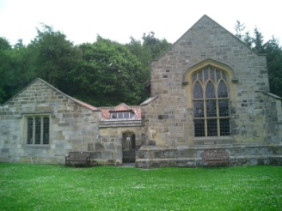
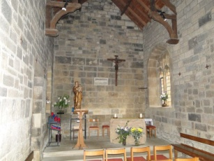
MARRIAGE APPLICATION FORM
THE SHRINE OF OUR LADY
MOUNT GRACE
OSMOTHERLY

Please complete the form below
Date of Marriage: ……………………………………………… Time: …………………………… Duration of Visit: ….………
Names of Couple: ……………………………………………………………………. Contact No: ………………………………………..
……………………………………………………………………. Contact No: ………………………………………..
Email:
Priest Presiding: ……………………………………………………………………. Contact No: ………………………………………..
(If a priest from outside the Diocese of Middlesbrough is presiding a Celebret will be required)
Will there be a Nuptial Mass or Marriage Service: ……………………………………………………………………………………
(Please tick as appropriate)
Has Marriage Preparation taken place: Yes: No:
Is the Shrine’s Registrar required? Yes: No: Fee: £47.00
Is a Musician Required? Yes: No: Fee: £60.00
Church Fee: £400.00

FLOWERS: and decoration of the chapel is to be arranged by the couple or their representative
CAR PARKING: There is limited parking available so if possible, please walk up to the Shrine. In your preparations, please take into consideration inclement weather conditions.
RECORDED MUSIC The Shrine does not have a license for recorded music so is unable to play recorded music via CD etc
To confirm your booking please return the completed form to
Sarah Holmes, Diocese of Middlesbrough
50A The Avenue, Middlesbrough TS5 6QT

