|  |  |  |  |  |
| --- | --- | --- | --- | --- |
|  |  | |  | | --- | | **Friends**  **of the**  **Lady Chapel** | | Autumn 2020 | |
|  |  |  |
|  |  |  |

Dear Friends

I do hope you are keeping safe and well during this challenging year.

Whilst many places of worship have been closed during the coronavirus pandemic, the doors to the Lady Chapel have remained open, albeit without Mass, and this oasis of peace has continued to sustain visitors and passers-by alike.

Between lockdowns Mass did return on a Saturday afternoon, at the earlier start time of 3pm, which will be the usual time going forward. A risk assessment has been prepared in order to comply with covid-19 safety guidelines and a total of 10 people can be accommodated within the Chapel. A further 15 can be seated in the barn area but unfortunately there will be no offer of hospitality after the Mass until further notice, due to safety restrictions.

Much of the work that was planned for the Lady Chapel this year, such as the new canopy design and placing of the stone altar, has had to be postponed due to the coronavirus outbreak. You will see from the photograph above that smart new signage for the Lady Chapel

has been placed at the bottom of Rueberry Lane.

Also, the defibrillator mentioned in the last newsletter has now been installed. Hopefully it will never be needed, but it is reassuring to know that it is there just in case.

A Cleveland Way diversion has been proposed which will mean that the Lady Chapel is visible from the new route and from only around 30 yards away. This could well bring more visitors and offer a perfect place to pause on a long country walk. Consultation is underway and I hope to bring you news on this in 2021.

The “Friends” page on the website has now been linked to the Virgin Money Giving donation system, making it simple for people viewing the site to make online donations directly to the Lady Chapel should they wish to at <https://www.ladychapel.org.uk/friends/>

The Goodbox contactless electronic card system within the Chapel has continued to receive a steady stream of donations, even during lockdown, and I send thanks

to all who have continued to provide financial support, particularly during this difficult time.

Finally, a huge note of thanks goes to Mick Campbell, who has stepped down after volunteering tirelessly for many years in all weathers and keeping things in order at the Lady Chapel. His work has been invaluable and is hugely appreciated.

Wishing you a peaceful Christmas and a happy new year.

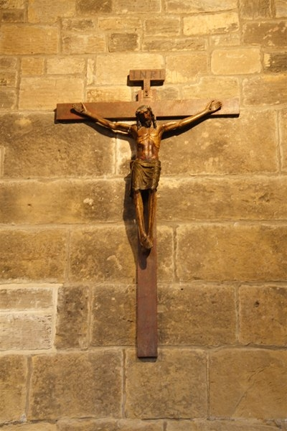

**DIARY DATES 2020**

### P:\The Lady Chapel, Mount Grace\Images\50d_1143.jpg

**Unfortunately there will be no Christmastide Masses**

**for 2020 due to the coronavirus pandemic and government restrictions on numbers. We pray that next year we can resume**

**as normal.**

Whilst there have been no bookings by schools or groups this summer, due to the pandemic, looking to next year, anybody wishing to make a booking at the Lady Chapel should email Alex Corser at [parish@middlesbroughrccathedral.org.uk](mailto:parish@middlesbroughrccathedral.org.uk). All events will be subject to Government guidance and may be postponed if there is a lockdown in place. Please remember that any visiting Priests will need to provide a valid Celebret in advance if they wish to celebrate Mass.

*Did you know that schools can be “Friends of the Lady Chapel”? If you work in a school and wish to sign up, please contact Sarah Holmes by email* [*bishopsecretary@rcdmidd.org.uk*](mailto:bishopsecretary@rcdmidd.org.uk)

*If it is more than 12 months since your last donation and you wish to make another, please send a cheque payable to “Diocese of Middlesbrough”, and don’t forget to let us know if you can Gift Aid the donation, as we can claim a further 25%. We also now have an option to pay by Direct Debit. Please contact* [*bishopsecretary@rcdmidd.org.uk*](mailto:bishopsecretary@rcdmidd.org.uk) *for details. Many thanks for your continued support.*

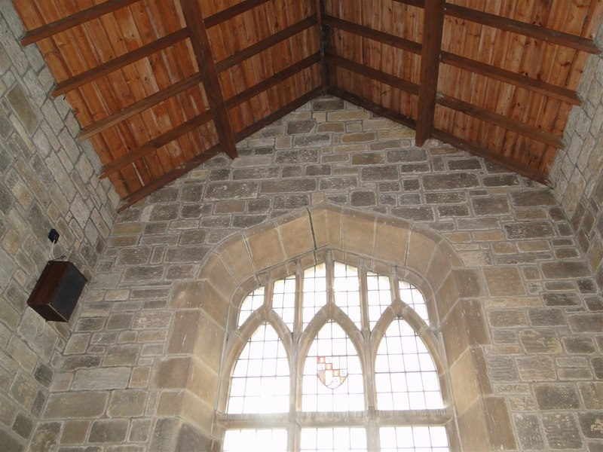

***If you have received this newsletter by post and would prefer to receive it by email in future, please let Sarah have your email address***.

**Website: www.ladychapel.org.uk**

In line with the implementation of GDPR in May 2018, please be assured that the personal information you have supplied to the Diocese of Middlesbrough as part of your Friends of the Lady Chapel application will be kept securely and only used to send you information about the Lady Chapel. It will not be disclosed to any third parties.