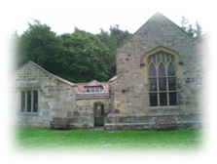
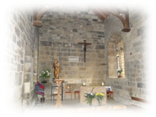
APPLICATION FORM
THE SHRINE OF OUR LADY
MOUNT GRACE
(For all Events)

ORGANISATION: ……………………………………………….  Address: ……………………………………………….  ……………………………………………….  ……………………………………………….  Contact Person: ……………………………………………….  Tel No: ……………………………………………….  Email: ……………………………………………….  Number in Party: | DATE OF EVENT:  Arrival Time:  Departure:  Tick Appropriate box  YES NO  Requirements: Chapel:    Barn:    Piety:    Beverages:    (Donation required)
Brief description of the event: | Will there be Mass:    Will there be a Service:    Adoration of the Blessed Sacrament    Stations of the Cross:  
Wedding Fees: (to be paid one month in advance)  Church Fee: £400.00  Registrar Fee: £47.00  Musician Fee: £60.00  Flowers: TBA  Stole Fee for visiting Celebrant to be paid directly to the priest concerned (£90.00) | Is a Shrine Priest required:    If not, name of Priest: ……………………………………………………  From which Diocese: …………………………………………………...  Is a Registrar required:  
Please Note:
- DONATIONS: All groups are expected to make a donation of between £50 - £100 towards the upkeep of the Shrine (Made payable to: ”The Lady Chapel”)
- RECORDED MUSIC: The Shrine does not have a license for recorded music so is unable to play recorded music via CD etc.
- SAFEGUARDING: Any school group visiting must conform to the Diocese of Middlesbrough Safeguarding requirements
- CAR PARKING: There is limited parking available so if possible, please walk up to the Shrine
For Official Use  Welcomer notified:  Sacristan notified:  Shrine Priest notified:  Registrar notified: | To confirm your booking, return this form to:  Christa Kamanga, St Mary’s Cathedral, Dalby Way, Coulby Newham, Middlesbrough TS8 0TW  Email: christa.kamanga@rcdmidd.org.uk  Tel No: 01642 597750  Please make all cheques payable to “The Lady Chapel”

It is the responsibility of the user to provide their own Risk Assessment (forms can be provided)

